HR Pro – Security Manager

Introduction

HR Pro Help Files provide details of system functionality. These may help to answer questions on the use of the system. They also contain contact details should further assistance be necessary.

HR Pro Security Manager : 3.2
Help File Build : 3.2.9

The Basics: Getting In And Out

The following mini-chapters show some basic operations necessary to get in and out of the Security Manager and screens you may encounter when doing so.

Login
Go to the Start menu and select Programs and then HR Pro Security Manager or Double Click on the HR Pro Security Manager shortcut on the Desktop.

The following screen will be displayed for SQL Users:

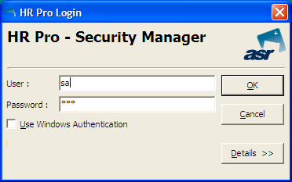

The User name will show the last User to log in on that pc but it can be overtyped to show a different user name.

Type in the Password which will be shown on screen as *******. Then Click the OK Button to log in.

If the Details button is clicked the screen will be expanded to show the Database and Server. Click the Details button again and the Database/Server options will then be hidden.

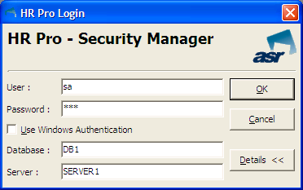

The following screens will be displayed for Windows Authentication Users:

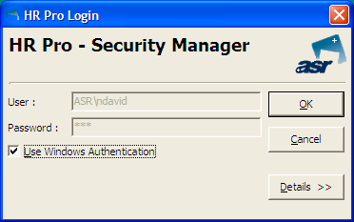

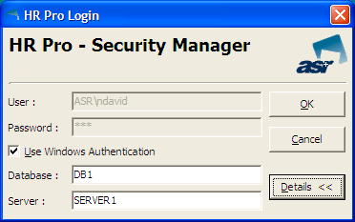

The Database and Server will remain populated once data is entered for the first time.

System Locked

In the Security Manager, there is an option to lock the system. This means that the user who locks the system can make changes to the system and security and then log into the Data Manager and test their changes.

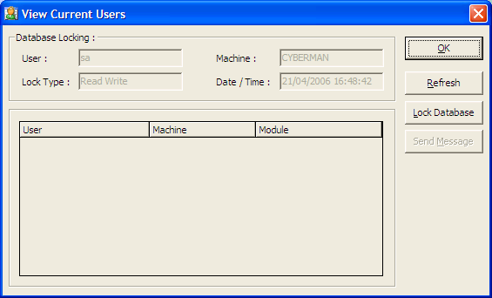

If any other user tries to log into the Data Manager whilst the system is locked they will get the 'System Locked' message.

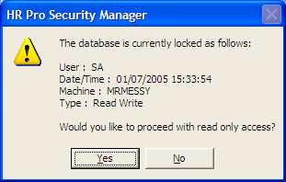

The system will remain locked until the user who locked the system logs into the Security Manager and unlocks it.

Save

Click Module and then select Save to save all changes back to the Server.

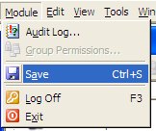

A prompt will be displayed asking the User to confirm that they wish to save the changes.

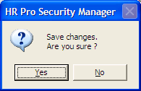

Click the Yes button to confirm the save.

If Exit is chosen or Security Manager is closed with the Windows close button and changes have not been saved a prompt will be displayed asking the user whether they wish to save the changes. Click the Yes button to confirm the save or Click the No button to exit without saving.

Log off

Click Module and then select the Log off option.

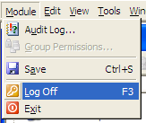

You will then get the standard, “Are you sure…” message.

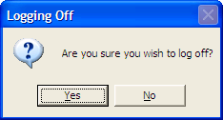

Click Yes if you are sure

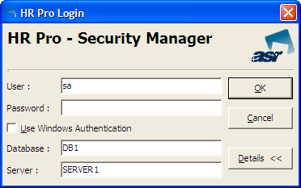

This will log the user off the database and return you to the Log in Screen ready for another user to log in, if required.

Pressing the Cancel button on Log in screen will take the user to the pc desktop.

Exit

Click Module and then select Exit…

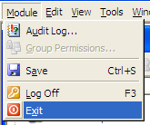

HR Pro Security Manager will be closed and the user will be taken back to the pc desktop.

Audit Log

From the Module menu, choose the option Audit Log. You will be presented with the Audit Log screen.

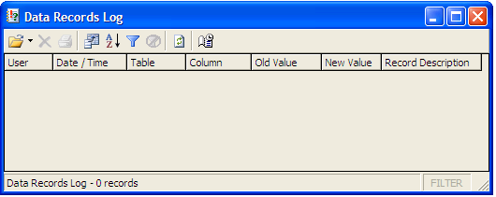

The following tool bar is available:

- Open – Specifies which Audit log is shown.
- Delete - Deletes all log records in the current view.
- Print - Prints all log records in the current view.
- Show/Hide Columns - Specifies which columns are to be shown in the current view. Options vary depending on which Audit Log is being viewed.
- Sort - Specifies the order in which the log records in the current view should be shown. Options vary depending on which Audit Log is being viewed.
- Filter - Filters log records shown in the current view. Options vary depending on which Audit Log is being viewed.
- Clear Filter - Clears current filter (only accessible if a filter is in use).
- Refresh - Pulls through up-to-the-minute audit data from SQL Server.
- Schedule Purge - Allows you to specify if and when the various Audit Logs should be automatically cleared out.

Audit Open

The Audit Log will always open by default into the Data Records Log.

Click the Arrow to the left of the Open icon. This displays a list of audit logs you can open, which are explained on the next page alternatively, Click the picture on the Open icon and the following screen will be displayed:

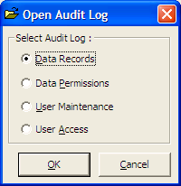

The screen gives the user the choice of four of Audit Logs:

- Data Records
- Data Permissions
- User Maintenance
- User Access

Data Records Log

This shows all changes to the data held in columns which have been flagged for audit. The Data Records Log can be very useful for monitoring changes to data in sensitive areas.

Any added or deleted records that have been set to Audit in the System Manager will also be shown on this log.

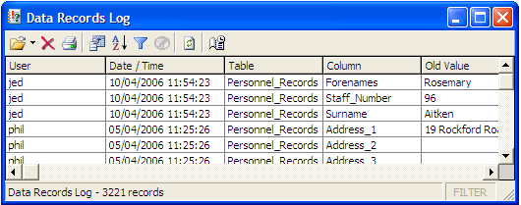

Data Permissions Log

This shows all changes and additions made to the Data Permissions of the various User Groups. It is useful for monitoring the usage of the Security Manager.

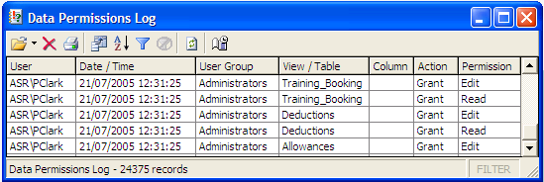

User Maintenance Log

This shows the creation and/or deletion of all new Users and User Groups. Used in conjunction with the Data Permissions Log, it can be useful for monitoring the usage of the Security Manager.

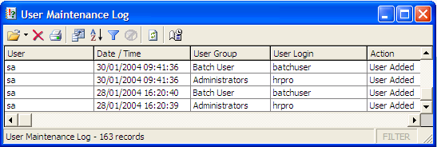

User Access Log

This shows the activity of the various users - which modules they logged into and out of, when the action was performed and on which computer.

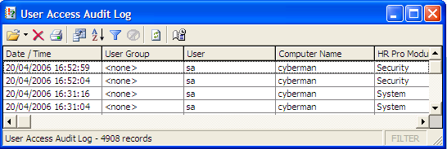

Audit Delete
From within the Audit Log all audit records in current view can be deleted. To do this Click the Delete icon.

Audit Print
From within the Audit Log Click the icon and the following screen will be displayed:

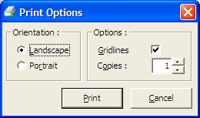

The default Orientation is Landscape. Click the option button for Portrait if this is preferred.

Grid lines are applied by default but can be removed by Clicking the Grid lines check box. This will remove the tick from the box and the Grid lines from the printed Audit Log.

Specify the number of Copies required and then Click the Print button.

The Cancel button cancels the Print Options and returns the user to the Audit Log screen.

Audit View

The Show/Hide Columns icon allows the user to change how the Audit Log is displayed.

Open the Audit Log and Click the Show/Hide Columns icon and the following screen will be displayed:

NB The options shown depend on the area of the audit log that you are currently viewing. The example below is from User Access'

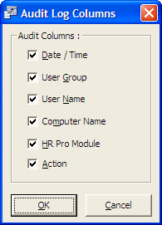

All Columns for the Audit Log chosen are shown by default.

If you do not wish to see a column in the Log Click the check box next to the Column Name and the tick will be removed. When the report is run this Column will not appear.

To add the Column back return to the Audit Log Columns screen.

Audit Sort Order
From within the Audit Log Click the Sort icon and the following screen will be displayed:

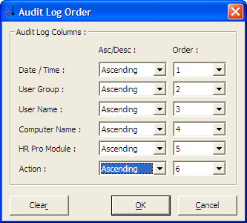

Each column can be sorted as Ascending or Descending. The default Order is Date but this can be changed by using the Order drop downs as in the example above.

To clear any sort orders setup in Audit Log Order screen Click the Clear button.

Audit Filter
From within the Audit Log Click the Filter icon and the following screen will be displayed:

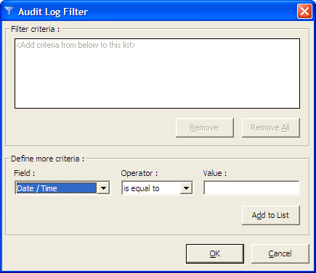

The Audit Log can be filtered on one or a combination of its columns i.e. Date/Time, User Group, User, Computer Name, HR Pro Module, Action.

The Criteria follows a pattern of Field, Operator, Value. Select each one in turn and then Click the Add to List button.

Add as many criteria as required and then Click the OK Button and the list will be filtered accordingly.

To remove a filter from the audit log Click the Clear Filter icon.

Audit Purge

By default, the Audit Log will not purge itself and will store audit information on a permanent basis. The user can specify which information to purge.

If you wish to purge the Audit Log on a regular basis to clear out old information, Click the Schedule Purge icon and the following screen will be displayed:

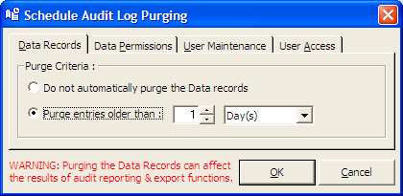

The example shown above has been set to purge the Data Records Audit for all entries older than 1 day. Each Audit Log type has a tab on this screen and the purge specifications are separate for each one.

It is difficult to specify categorically how often the Audit Logs should be purged as different organisations will track more or less Data Records audit information. However, we recommend that an average system with a few fields flagged for audit should be purged at least every six months.

You will also see the warning message which appears in red on the screen above to ensure you have selected the right options before you Click the OK Button.

Group Permissions

New User Group
From the Module menu, choose Group Permissions. The following screen will be displayed listing all existing User Groups.

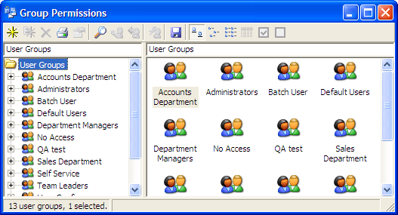

Either Click the New icon or right mouse Click in the right-hand side of the screen to view the Context Sensitive menu to add a new User Group. The following screen will be displayed:

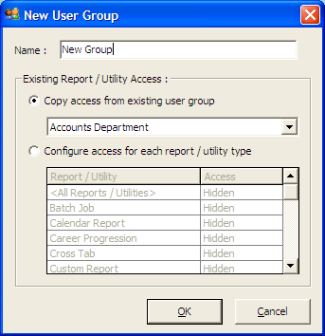

Type in the name of the User group i.e. Managers.

The Existing Report / Utility Access is used to assign attributes for your new User Group.

The Copy access from existing user group enables you to apply access rights from existing User Groups quickly.

The Configure access for each report/utility type allows you to quickly assign Read / Write, Read Only, Hidden attributes to reports and utilities quickly at design time. You are now able to select the Default Access for a new user group to <All Reports/Utilities>.

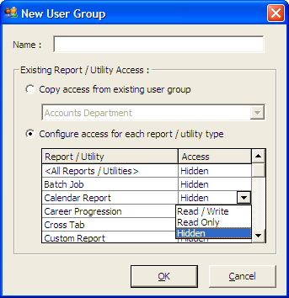

Click the OK Button to create user group.

Once the User Group has been created it comprises of three parts as shown in screen below:

- User Logins
- Data Permissions
- System Permissions

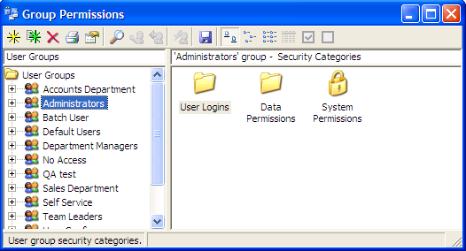

User Logins

This is where the User Logins and Passwords are created for all the new users belonging to the User Group.

There are several user login types these are listed below:

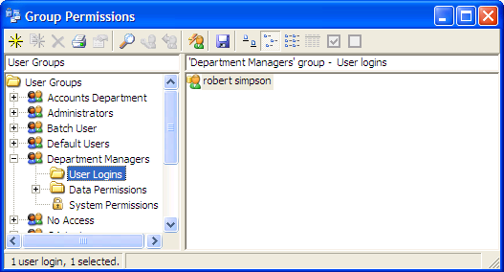

SQL User: These are created by using SQL Server Authentication. This means that when the user is created a user login and password are stored on the SQL server, the user then logs in using those details.

Windows User: These are created by using the login details stored on the Windows Domain. This means that the user would log in to HR Pro using the Windows authentication option SQL server then picks up the user’s network login and validates it.

Windows Group: These are created in the same way as a Windows User. A Windows Group is a collective list of users that have the same access to windows, rather than adding each user individually if all the users are part of same group for windows add the Windows Group to HR Pro. When the users of that group log in to HR Pro using windows authentication the SQL server picks up the user’s network login and validates it (as long as the user is part of the Windows Group added).

Create a SQL user

From the Module menu, choose Group Permissions.
On the left hand side Click the User Group that the new User login should belong to.
On the right hand side double Click the User Logins folder.
Click the button, or right Click in the right-hand side of the screen and choose New. The following dialog box will be displayed:

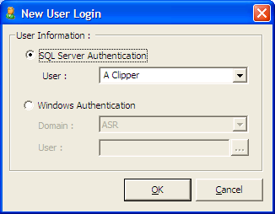

Ensure the SQL server Authentication option is selected.
Type in a new User Login as appropriate, remembering the following:

- It must be unique - not currently in use elsewhere in any User Groups.
- It cannot contain symbols.
- Max length 50 characters.

Only someone logged in as the SQL Server Administrator can create users that are new to both the SQL server and HR Pro. If an administrator is logged in with any other user name then Users can only be chosen from a list of those logins that already have SQL Server access permission.

When done, Click the OK Button. The following dialog box will appear:

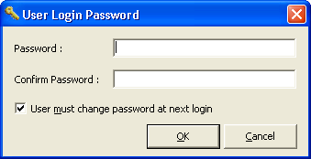

Type in a Password as appropriate, and then confirm it by entering it a second time.

Passwords should fit the following criteria: Maximum of 30 characters. See the ‘Security Options’ section for configuration options relating to passwords.

The checkbox labelled User must change password at next login allows the administrator to force the HR Pro user to re-enter their password when they next use the software.

When done, Click the OK Button. The new user will appear in the right-hand side of the screen.

Create a Windows User or Windows Group login

From the Module menu, choose Group Permissions.

On the left hand side Click the User Group that the new User login should belong to.

On the right hand side double Click the User Logins folder.

Click the button, or right Click in the right-hand side of the screen and choose New. The following dialog box will be displayed:

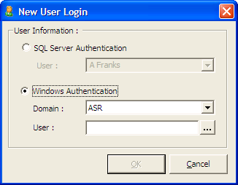

In the area marked Windows Authentication choose the Windows Domain option. From the list choose the Domain the Windows User and or Group belongs to and then Click the button.

The following dialog box will appear:

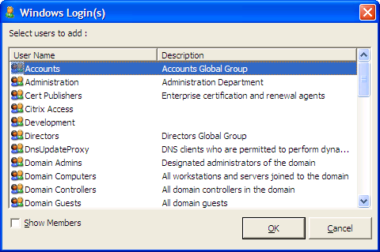

The ellipse button brings up the following list of Groups. Click ‘Show Members’ to select a Member from a Group.
Once a Group or Member is selected the User Login field will be populated, as shown below:

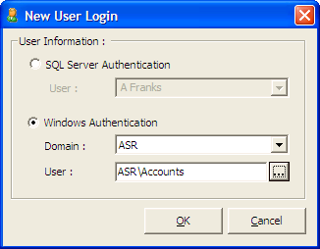

Type in a new User Login as appropriate, remembering the following:

- It must be unique - not currently in use elsewhere in another User Group.
- It cannot contain numbers.
- It cannot contain symbols.
- Max length 128 characters.

Only someone logged in as the SQL Server Administrator can create entirely new users. If you are logged in as any other user, you will only be able to choose users from a list of those who already have basic SQL Server access permission.

Click the OK Button and the New User will appear in the right-hand side of the screen as below:

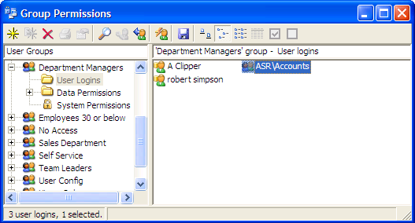

Creating Multiple Logins

From within Group Permissions screen you can create users from the records stored in HR Pro.

Click the User Logins folder and then Click the Automatic Add Users icon on the tool bar.

The following screen will be displayed, with the default of SQL Server Authentication:

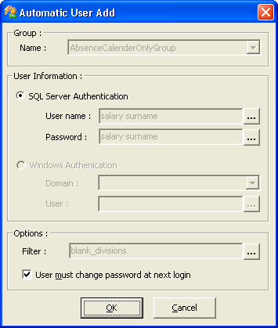

Click the button next to User Name.

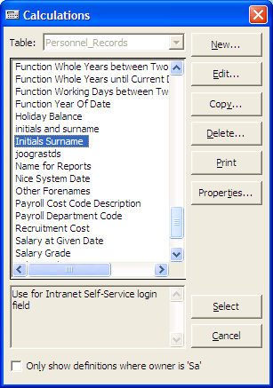

Here a calculation must be chosen. The calculation will be the structure for the User names that the system will automatically generate. For example; Surname & Initials. You can create new calculations or Highlight an existing calculation and Click the Select button.

Click the button next to Password.

Here a calculation must be chosen. The calculation will be the structure for the Passwords that the system will automatically generate. For example; surname & Postcode. Highlight the required calculation and Click the Select button.

Click the button next to Filter and the following screen will be displayed:

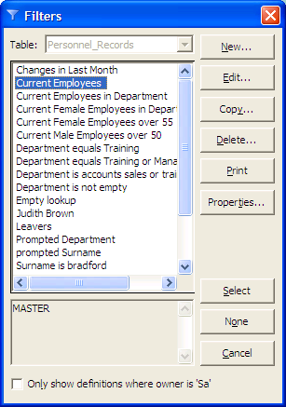

To create a new Filter Click the New button and the Filter screen will be displayed:

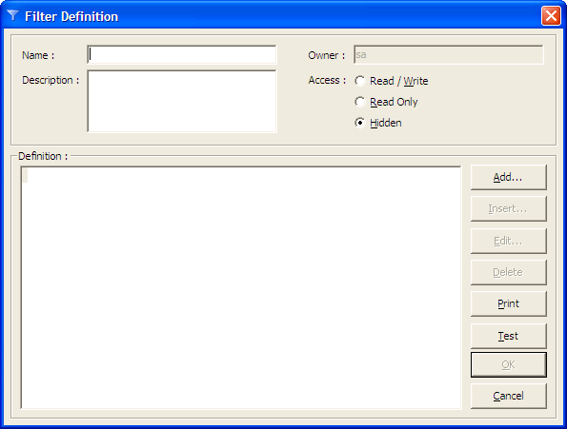

Type in a Name for filter and Description if necessary.

When any Expression (Calculation, Filter, Order etc) is defined the Definition window will be displayed to show the Expressions. The user can Add, Edit, Copy, Delete, Print or Test the expression before the OK Button is clicked.

To create a new expression i.e. only filter staff in the Personnel Department Click the Add button and the Expression component screen will be displayed:

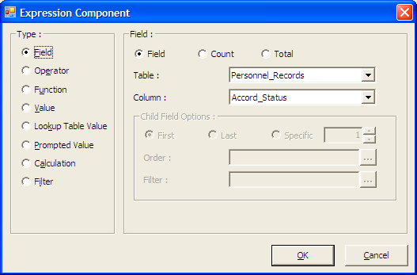

Click the Add button and the Expression Component screen will appear. Build the Filter using the components required.

Simple Filters often follow the Field, Operator, Value rule. More complex calculations can include functions and other calculations.

Once the Filter has been created Click the OK Button in the filter definition screen then Click Select button to select the filter.

Ensure the User must change password at next login checkbox is ticked. This forces the user to change the password from the automatically generated one to a value they will remember easily.

Click the OK Button and a report will be displayed showing the names of the Users about to be created.

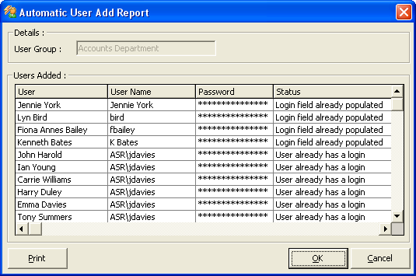

Click the Print button to obtain a list of new logins.

Click the OK Button and the Users will appear in the User Logins folder.

The User name will also appear in the Intranet Self Service login column on Personnel Records. (This will only happen if the Module set up is correct)

Find User

The Find User functionality will enable the user to quickly locate individuals in your User Groups.

In the example below we have three typical user groups that you may find in a HR Pro Security Permissions system: Administrators, Batch User, Default Users.

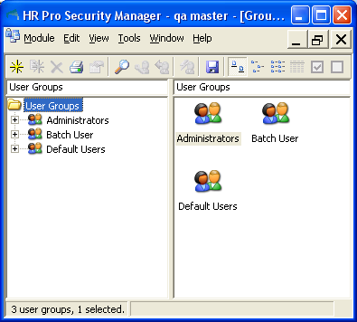

We want to find a user Dennis Magee and know he exists in one of the groups.

Now you could go into each group one at a time and you will be sure to come across him eventually. This would be quick enough if you only have three user groups to look through, however, some HR Pro systems will have many User Groups and therefore this would be a very time inefficient way of searching for Dennis.

Instead select the Find User button to call up the following screen.

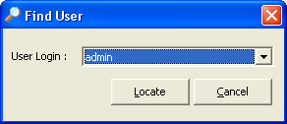

It will default to the login that is alphabetically first in the list – in this case it is admin.

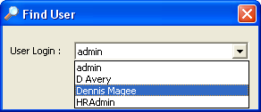

Use the dropdown to find the user you want to find and highlight his name. We wanted Dennis so he had been highlighted.

When he is selected the screen will go back to the state below where you must click the Locate button to start the search.

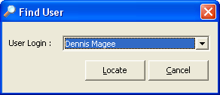

He should exist as he was present in the list above.

The Permissions screen will come back to the fore with Dennis Magee’s group expanded and his icon highlighted.

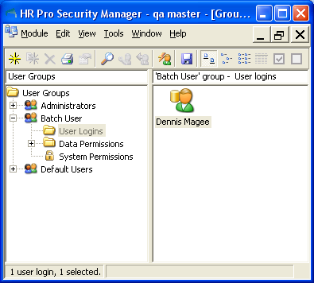

Moving User Logins
If a User Login is created in the wrong user group it can be moved using the Move icon.

Select the user login you wish to move, then Click the Move icon and the following screen will be displayed:

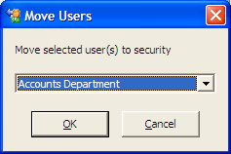

Select the group you wish to move the user login to then Click the OK Button.

Expression Components
When building Filters and Calculations the Expression Components screen is displayed below. The following are the Components that are available:

Field
Click the Field option in the Type area of the screen. The Table will default to the Base Table. If a different table is required to gain access to other fields,

Click the drop down arrow and choose the correct table.

Next Click the drop down arrow and choose the correct Column. You can type the first letter of the field required. The list will move to the first field name beginning with that letter. Scroll down and Click on the required field name.

Click the OK Button to return to the Filter Definition Screen.

Operator
Click the Add button to display the Expression Component screen.
Click the Operator option and the box on the right hand side of the screen will change to show the available operators.

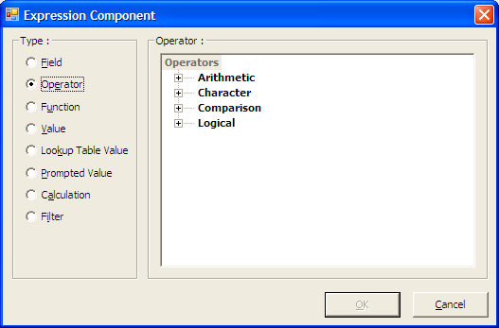

The Operators are broken down into four basic types Arithmetic, Character, Comparison and Logical.

Logical And/Or

If the filter expression has more than one section then the sections must be joined by either an And or an Or. Click the Add button in the Filter definition screen and choose Operator.

In the Logical section double Click either the And or the Or. Then continue adding Field, Operator and then Value.

Using all AND’s in your expression will give a group of records that conform to all the criteria expressed in the Filter.

Using all OR’s will give a group of records that conform to at least one of the criteria expressed in the Filter.

Function
A function can be described as a set of instructions that carries out a defined task and returns a result (value). Functions can be used within Filters or Calculations.

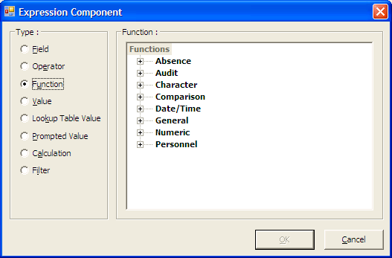

Most functions require the input of information and these pieces of information are usually referred to as parameters.

When a function is required in a Filter or Calculation Click the Function option.

The Functions are broken down into 8 basic types Absence, Audit, Character, Comparison, Date/Time, General, Numeric and Personnel.

To expand the required list, Click the cross next to the type name. Click the minus to reduce the list again.

E.g. in the two screen shots below we have the list of function groups on the left. On the right after Clicking the cross next to Absence.

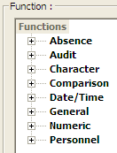

the group expands to show that Absence contains two read made functions: ‘Absence between Two Dates’ and ‘Absence Duration’

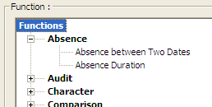

Highlight the required function and Click the OK Button.

Click on <Bracket Name> to highlight it and the Click the Add button. On the Expression Component screen choose the required field, function, value or calculation and Click the OK Button.

Value
Click the Value button and the following section becomes available:

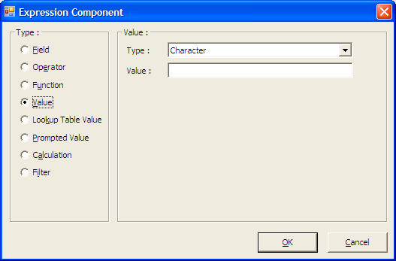

Choose the Type of Value that is required e.g., Character, Numeric. Logic or Date.

Then in the next box either choose or enter the Value required.

Click the OK Button to add the Value to the Expression Definition screen.

Lookup Table Value
Click the Add button to display the Expression Component screen.

If the Value required is from a field with a lookup table, the Lookup Table Value option is used.

Click the Lookup Table Value option and the following section becomes available:

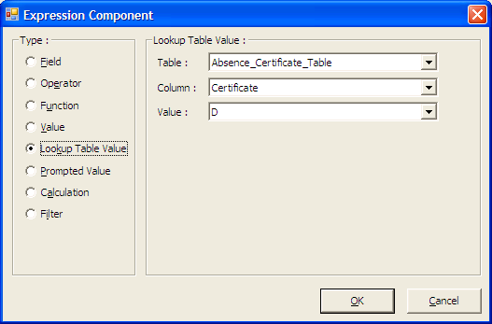

Choose the Table: name required. Usually the table has been named the same or similarly to the field it is associated with.

Choose the Column: if there is more than one on the table.

Choose the Value: required and Click the OK Button to add it to the Expression Definition screen.

Prompted Value
If the value required is a prompted value the Prompted Value option is used.

Prompted values allow the user to enter the value when the report, mail merge etc containing the Filter is run. The following screen is an example of the prompted value definition screen:

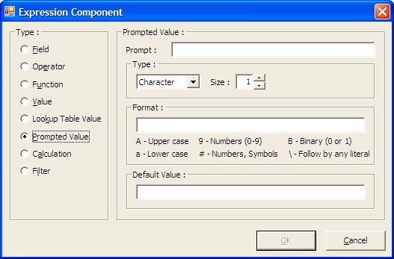

Click the Type dropdown and choose the value type required. The options on the screen change depending of the type chosen.

Table - a table and column must be chosen.
Numeric - a size must be given.
Character - a size must be given and a format may be used.

In the Prompt area type the text that will advise the user how to enter the required value e g “Choose the required Department” or “Type the required salary”

In the Default area, choose or type the value that needs to be shown in the prompt box when it appears on screen. Setting your own default value is optional.

Calculation
Sometimes it is useful to incorporate an existing calculation into the new expression being created. This is commonly done with the ‘Current Employees’ filter, to ensure that leavers are excluded.

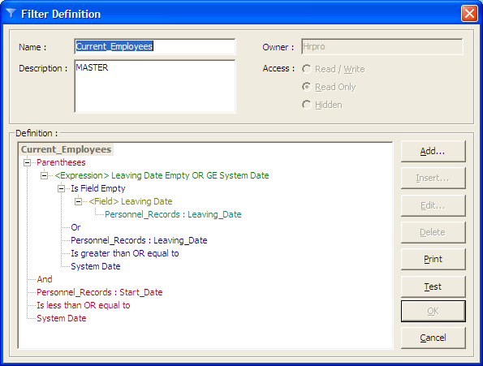

Click the Add button to display the Expression Component screen.

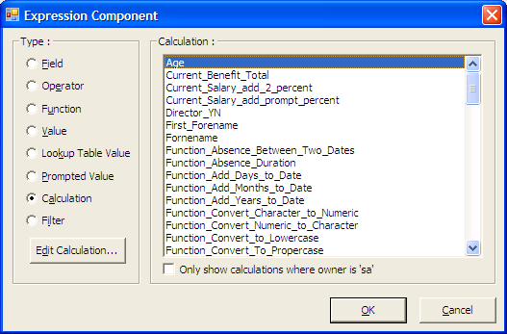

Click the Calculation option and the right hand side of the screen will change to show the available Calculation.

Highlight the required Calculation and Click the OK Button.

For a Calculation that has been marked as Read only, the button on the left-hand side will display View Calculation otherwise it will be Edit Calculation.

Filters
Sometimes it is useful to incorporate an existing filter into the new expression being created. This is commonly done with the ‘Current Employees’ filter, to ensure that leavers are excluded.

Click the Add button to display the Expression Component screen.

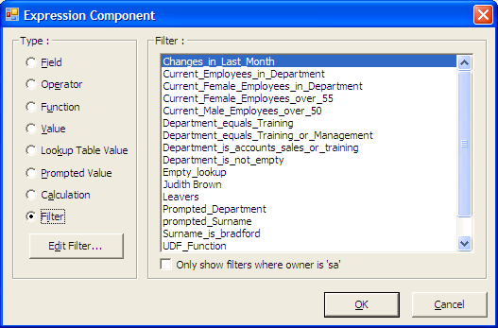

Click the Filter option button and the right hand side of the screen will change to show the available Filters. Highlight the required Filter and Click the OK Button. For a Filter that has been marked as Read only, the button on the left-hand side will display View Filter otherwise it will be Edit Filter.

Expression Functions

Absence

Absence Between Two Dates (SQL 2000 AND ABOVE)

This function calculates the number of working days lost due to a specific Absence Type in a set period taking into account bank holidays and the working pattern of the employee.

<Start Date>
<End Date>
<Absence Type>

Example: This function could be used to calculate the number of days sickness a member of staff has taken in a year.

Absence Duration (SQL 2000 AND ABOVE)

This function calculates the number of working days in an absence period taking into account half days, bank holidays and the working pattern of the employee.

<Start Date>
<Start Session>
<End Date>
<End Session>

Example: This function could be used to calculate the number of days holiday taken with an absence period.

Audit

Field Changed Between Two Dates

This function returns true if an audited field has been changed between two given dates.

<Audit Field>
<From Date>
<To Date>

Example: This function could be used to calculate if a salary has changed in the current year.

Field Last Changed Date

This returns the date a given audited field was last changed.

<Audit Field>

Example: This function could be used to calculate the date the Manager for an employee was last changed.

Character

Convert Character to Numeric

Returns a type Numeric equal to a numeric value held in a value of type Character.

Example: Where a probation period is held as 4 Weeks or 3 Months the character value must be converted to numeric if it is to be used in conjunction with other functions like Add months to date to generate a Probation end date.

Convert to Lowercase

Returns a value of Character type for the string specified with all the alphabetic characters within that string converted to Lowercase.

Example: This will return the value ‘abc’ from the values of 'ABC', 'AbC' etc.

Convert to Proper case (SQL 2000 AND ABOVE)

Returns a value of Character type for the string specified with all the alphabetic characters within that string converted to Proper case.

Example: This will return the value ‘Abc’ from the values of ‘ABC, ‘aBC’ etc.

Convert to Uppercase

Returns a value of Character type for the string specified with all the alphabetic characters within that string converted to Uppercase.

Example: This will return the value 'ABC' form the values of 'Abc', 'AbC' etc.

Extract Characters from the Left

Returns a character string containing a specified number of characters from the left of the specified character string.

<String>
<Number of Characters>

Example: This could be used to obtain a list of all Temporary tax codes when the first two letters are "TN"

Extract Characters from the Right

Returns a character string containing a specified number of characters from the right of the specified character string.

<String>
<Number of Characters>

Example: Where the character String is 'abcdefg' and the Number of Characters is 3, the returned value will be 'efg'.

Extract Part of a Character String

Returns a character string containing a specified number of characters from a specified start position in a specified character string.

<String>
<Start Position>
<Number of Characters>

Example: Where the character String is 'abcdefg' and the Start Position is '3' and the Number of Characters is '2' the returned value will be 'cd'.

First Name from Forenames

Returns an individual's first name from a Forenames field, which may contain several names separated by spaces.

Example: This is used in the 'Known as' field on the standard system.

Initials from Forenames (SQL 2000 AND ABOVE)

Returns an individual’s initial from a Forenames field, which may contain several names separated by spaces.

Example: ‘Sarah Jane’ will return S J.

Length of Character Field

Returns a value of type Numeric equal to the length of a character field or any character string.

Example: This could be used to validate fields to stop abbreviations being overused e.g. County could be set to at least 6 characters.

Remove Leading and Trailing Spaces

Returns a character string equal to a specified string with any spaces removed from the beginning and the end.

Example: This is used to trim fields if they have extra spaces in the data. The value ' abc' would be returned as 'abc'.

Search for Character String

Returns a numeric value equal to the starting character position of the string within a second specified string.

Example: Where the String is 'abcdefg' and Search for is 'cd' the returned value will be '3'.

Comparison

Is Between

Returns True or False depending on whether a specified value is between specified minimum and maximum limits

<Test Value>
<Minimum Value>
<Maximum Value>

Example: When reporting on leavers this function could be used to check for all leavers whose Leaving date is between 1 January and 31 December. All parameters must be the same type but the function can be used for numeric or date types.

Is Field Empty

Returns True or False depending on whether the specified field is empty.

Example: This could find all staff who do not have a Bank account number, Leaving date, Pension entry date etc.

Is Field Populated

Returns True or False depending on whether the specified field is populated.

Example: This could find all staff that has a NI number populated

Maximum

Returns the highest of two numeric values.

<Numeric 1>
<Numeric 2>

Example: The Numeric or Numeric results of calculation would be compared and the higher of the two values would be returned to the field.

Minimum

Returns the lowest of two numeric values

<Numeric 1>
<Numeric 2>

Example: The Numeric or Numeric results of calculation would be compared and the lower of the two values would be returned to the field.

Date

Add Days to Date

Adds a specified number of days to a specified date and returns the resulting date value.

<Start Date>
<Number of Days>

Example: A specified number of days can be added to a date to produce a future date for a follow up Interview or review.

Add Months to Date

Adds a specified number of months to a specified date and returns the resulting date value.

<Start Date>
<Number of Months>

Example: To generate an employee's Probation end date based upon their Start date and Probation period.

Add Years to Date

Adds a specified number of years to a specified date and returns the resulting date value.

<Start Date>
<Number of Years>

Example: To generate an employee's Next appraisal date or their Retirement date based on Date of Birth and Retirement Age.

Day of Date

Returns the numeric day of the month (between 1 and 31) from a specified date.

Example: This may be used to extract the day of an employee's start date for holiday/sickness calculations where entitlement for the first month of employment is only applicable for new starters before a certain day/number of the month.

Day of the Week

Returns a numeric value corresponding to the day of the week (from 1 for Sunday to 7 for Saturday)

Example: This may be used to make calculated probation ends or appraisal dates more accurate by checking whether such calculations produce a date corresponding to a weekend.

Days between two Dates

<Start Date>
<End Date>

Example: Could be used to calculate the turn around time in days from when a CV is received to an Application form being sent out.

First Day of Month

<Date>

Example: 16/11/2005 would return 01/11/2005

First Day of Year

<Date>

Example: 16/11/2005 would return 01/01/2005

Last Day of Month

<Date>

Example: 16/11/2005 would return 30/11/2005

Last Day of Year

<Date>

Example: 16/11/2005 would return 31/12/2005

Month of Date

Returns a numeric value between 1 and 12 corresponding to the month number of a specified date.

Example: The month number of 10/11/05 is returned as 11. This function could be used to report on birthdays in the current month.

Name of Day

<Date>

Example: 16/11/2005 would return ‘Tuesday’

Name of Month

<Date>

Example: 16/11/2005 would return ‘November’

Nice Date

Returns a character string equivalent to a specified date consisting of the day number, month in character form and a four digit year.

Example: This function will return the date value of 26/11/05 as the character string 26 November 2005.

Nice Time

Returns a character string containing the time in the format H: MM or HH:MM equivalent to a specified time.

Example: Interview times where the 24 hour clock may cause confusion for the candidates. 17.30 will be returned as 5.30 pm.

Remaining Months since Whole Years

This returns a numeric value equal to the number of complete months remaining between a specified date and the current date having allowed for any complete year which have elapsed.

Example: This could show the number of months someone has been in a post allowing for elapsed whole years. See also Whole Years until Current date.

Round Date to Start of Nearest Month

Returns a date value equal to the first day of either the current month or the next month depending on which is nearest a specified date.

Example: If the date is between 1 November 2005 and 15 November 2005 the date value '1 November 2005' will be returned. If the date is between 16 November 2005 and 31 November 2005 the date value returned will be '1 December 2005'.

System Date

Returns the current value of the system date.

Example: This is used in the Filter for Current Employees. If starters are added to the system before their actual start date the filter will exclude them by checking that Employees have started before the System Date (Today's date). Also useful in Rolling year reports.

System Time

Returns the current value of the system time.

Example: This could be used to record the time a record was last updated if the date alone is not precise enough.

Weekdays between Two Dates

Returns a numeric value equal to the number of weekdays in a specified period.

<Start Date>
<End Date>

Example: This function returns a numeric value of the number of weekdays (excluding Saturday and Sunday) within the period specified.

Whole Months between two Dates

Returns a numeric value equal to the number of complete months in a specified period.

<Start Date>
<End Date>

Example: This could be used to calculate the number of whole months of service if for example a pension scheme is available after 18-24 months of service.

Whole years between two Dates

Returns a numeric value equal to the number of complete years in a specified period.

<Start Date>
<End Date>

Example: This could be used to calculate the number of whole years of service if for example a pension scheme is available after 2 years of service.

Whole Years until Current Date

Returns the number of complete year from a specified date until the current date.

Example: The number of complete years in a job could be shown using this function. See also Remaining Months since Whole Years.

Working Days between Two Dates (SQL 2000 AND ABOVE)

Calculates the number of working days in a period taking into account bank holidays and the working pattern of the employee

<Start Date>
<End Date>

Example: This could be used to see how many working days a staff member has done in a month.

Year of Date

Returns a numeric value equal to the year element of a specified date including the century.

Example: This will return the numeric value '2001' from the date 01/06/05

General

Current User

Returns the Current User name.

Example: This could be used in a 'Last updated by' field and records the User name of the person who last saved the record.

Get Field from Database Record

Returns the contents of a specified field from a record, given the name of the database and an index expression for that database.

<Search Field> (passed by reference)
<Search Expression> (passed by value)
<Return Field> (passed by reference)

Example: This could return descriptions relating to specified code values from lookup tables.

In Personnel Records it may return a Department description from a Department Code from a Department lookup table.

The Search Field in this case is the Department Code on the Department lookup table.

The Search Expression is the Department Code in Personnel Records.

The Return Field is the Department Description field on the Department lookup table.

If…Then….Else

Returns one of two values depending on whether a specified condition is True or False.

<Condition>
<If Return>
<Else Return>

Example: If the employee is full time the standard hours could be defaulted to 37.5, else 20 hours per week.

Parentheses
Allows an expression to be isolated within parentheses (brackets) to ensure that the intended results are obtained

<Expression>

Example: When a filter contains AND and OR statements the use of parentheses ensures that it is interpreted as intended.

Numeric

Convert Currency

Returns the triangulated conversion of two currencies using the Euro.

<Numeric Value>
<From Currency>
<To Currency>

Example: This could be used to convert a numeric amount shown in one currency to the equivalent amount in Euros or currency compliant with the Euro.

Convert Numeric to Character

Returns a value of string type Character containing the specified numeric value, allowing the number of decimal places to be specified.

<Numeric>
<Decimals>

Example: Used to format the results of calculations.

Round Down to Nearest Whole Number

Returns a numeric value equal to the nearest whole number equal to or less than the specified numeric value.

Example: This could be used to round salaries down to the nearest whole number if the salary should be in pounds only and not include pence.

Round to Nearest Number

Returns a numeric value rounded to the nearest multiple of the number to round to.

<Number to Round>
<Nearest Number>

Example: With a Nearest Number set to '5', the function will return the value of '15' when the Number to Round is greater than or equal to 12.5 and less than 17.5. It will return a value of '10' when the Number to Round is greater than or equal to 7.5 and less than 12.5.

Round Up to Nearest Whole Number

Returns a numeric value equal to the nearest whole number equal to or greater than the specified numeric value

Example: This could be used to round salaries up to the nearest whole number if the salary should be in pounds only and not include pence.

Personnel

Is Personnel That Current User Reports To (Module Set-up Required & SQL 2000 AND ABOVE)

The current user will see those names above them in the Company Hierarchy.

Example: QA Consultant would see the names of their Manager, their Manager’s Manager and so on.

Is Personnel That Reports To Current User (Module Set-up Required & SQL 2000 AND ABOVE)

The current user will see those names below them in the Company Hierarchy.

Example: Training Manager would see the names of the Training executive(s), Training Assistant(s) and so on.

Is Post That Current User Reports To (Module Set-up Required & SQL 2000 AND ABOVE)

The current user will see those Posts above their Post in the Company Hierarchy.

Example: QA Consultant would see QA Manager and Development and Test Director and so on.

Is Post That Reports To Current User (Module Set-up Required & SQL 2000 AND ABOVE)

The current user will see those Posts below their Post in the Company Hierarchy.

Example: Training Manager would see Training executive and Training Assistant and so on.

Number of Working Days per Week

Returns a numeric value equal to the number of days an employee works in a week based on the effective working pattern field.

<Working Pattern>

Example: Where the Working pattern is ' MM WW FF ' the numeric value returned will be '3'.

Service Months

Returns a numeric value equal to the number of months service of an employee taking into account and deducting any complete years of service.

<Start Date>
<End Date>

Example: This is used to calculate the Service in months of an employee to the earliest of the leaving date or the current (system) date. When an employee has served 15 months, for example, the function Service years will return the value of 1 and this function will return the value of 3

Service Years

Returns a numeric value equal to the number of complete years service of an employee.

<Start Date>
<End Date>

Example: This is used to calculate the Service in complete years of an employee to the earliest of the leaving date or the current (system) date.

Data Permissions

This is where access rights to the data tables are specified. They are embedded within the SQL Server database itself. This ensures that access to the data is always regulated by the security settings configured in HR Pro – even when the data is accessed via third party applications (e.g. Crystal Reports).

There are two levels of data permissions:

Table/View Data Permissions specifies the access allowed to entire tables / views. For example, you may wish to stop users deleting from or adding to a particular History Table.

Shared Child Tables in the Security Manager can now specify access to a shared child table i.e whether is restricted to those records related to all or any of the permitted parents.

Column Permissions specifies the access allowed to individual columns within a specified table. For example, you may wish users to view the Job Title, Department and Grade in the Salary History but not be able to see the Amount column.

Table / View Data Permissions

On the left-hand side of the screen, Click Data Permissions. You will be presented with a screen similar to the following:

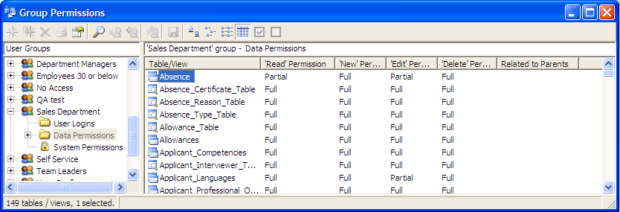

The right-hand side of the screen displays all the data tables within HR Pro and the current access levels for each one. Four different Views are available from the button bar. The example shown above uses the Details icon.

Each Table/View has four levels of access permission:

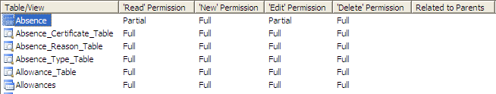

- Read allows the data to be viewed but neither added to, edited or deleted.
- New allows the user to create new entries in the table. ‘Read’ and ‘Edit’ permission must be granted as pre-requisites.
- Edit allows the user to edit existing data, but does not allow the creation of new items. ‘Read’ permission must be granted as a pre-requisite.
- Delete allows the user to delete existing data. ‘Read’ permission must be granted as a pre-requisite.

Table / View Data Permissions as described above control the general permissions or the entire table and will give either:

- Full – all columns within the Table/View can be accessed
- None – no access, as they control general permissions for the entire table.

A third option is Partial access which allows access to some but not all the columns in the Table/View. If you wish to specify Partial access, Column Permissions must be set.

N.B. When a new User Group is created, the only permission granted automatically is to be able to read the Lookup Tables – this is mandatory and cannot be revoked.

To change permission for a table, right Click over its name and choose Properties or Click the Properties icon and the following screen will be displayed for all tables other than Lookup tables:

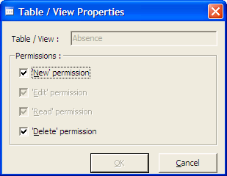

Change the settings as desired and then Click the OK Button.

For Lookup tables, the following screen will be displayed:

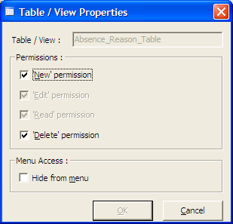

As you can see, there is an additional option of Hide from menu. If you check this for any Lookup Table, the Table name will not appear in the Lookup Table list in Data Manager or Data Manager Intranet modules.

If you are deleting ALL Permissions to a Parent Table and all it’s views, then the following message will appear:

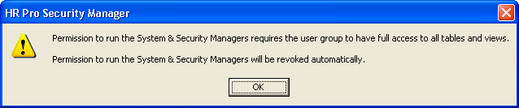

NB: You cannot delete ALL Permissions for a User Group that has System or Security Manager, Read/Write access.

Shared Chld Tables

In the Security Manager you can now specify if access to a shared child table is restricted to those records related to all or any of the permitted parents.

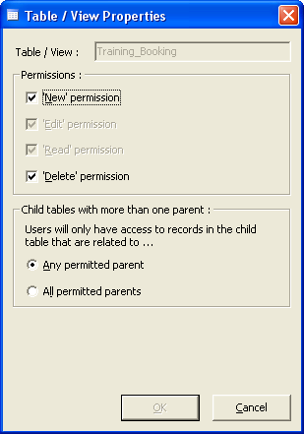

e.g. a shared child table Training Booking with two parents Personnel and Course Records.

If a user has permission to see the Course Records view of the Personnel table, and the Training Booking view of the Course Records table, then any permission will allow them to see all of the Training Booking records for all Course Records staff, and all Training Bookings for Personnel.

Selecting all permission will allow them to only to access the Training Records that link Course Records with Training Bookings.

Column Permissions

Expand Data Permissions folder on the left hand side of the Group Permissions screen and a list of all the data tables will be displayed.

On the left hand side Click on the Table you wish to work with and the table columns will be displayed.

The following screen shows the Absence Type table columns:

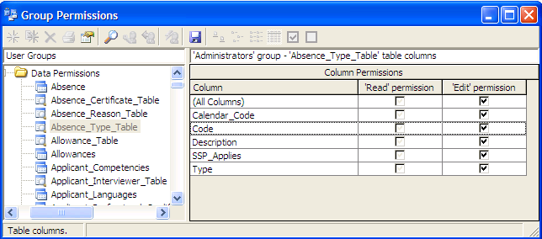

Click the checkboxes beside each Column Name to change the permissions for that particular column. Note that the permissions available do not include ‘Delete’ or ‘New’ – these belong to the entire table and are not possible on individual columns.

System Permissions

The System Permissions section allows you to specify which menu options the users should have access to.

Click the System Permissions option and the following screen will appear:

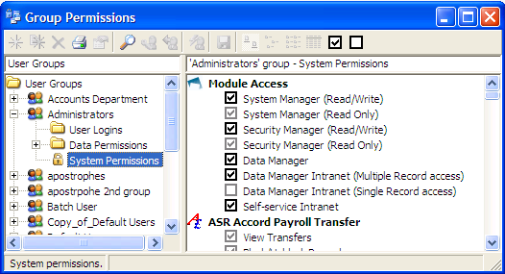

Grant System Permissions: Clicking on this icon will tick permissions to all permissions other than Module Access.

NB: Data Manager Intranet New User permissions will only be ticked if DMI Multiple Record Access has been granted in Module Access.

Revoke System Permissions: Clicking on this icon will un-tick permissions to all permissions other than Module Access.

Click the checkboxes as appropriate. The following options are available for each selection:

- New – the user can create new items of this type
- Edit – the user can change and modify existing items of this type
- View – the user can view but cannot edit existing items of this type
- Delete – the user can delete existing items of this type
- Run – the user can run existing items of this type

Note that New permission requires having ‘Edit’ and ‘View’ permission – these will be checked automatically when ‘New’ is granted. Similarly, Edit permission requires having ‘View’ permission - these will be checked automatically when ‘Edit’ permission is granted.

Module permissions for the Data Manager Intranet and the Self-service Intranet are granted individually.

Module Access
At the top of the right-hand side of the screen in the System Permissions area are checkboxes to give access to:

- System Manager (Read/Write)
- System Manager (Read only)
- Security Manager (Read/Write)
- Security Manager (Read only)
- Data Manager Intranet (Multiple Record Access)
- Data Manager Intranet (Single Record Access)
- Self-service Intranet

Tick the boxes if you wish to grant access to these modules of HR Pro.

Print Group Details
Click the Print icon on the menu bar or right mouse Click and select Print Details. The following screen will be shown:

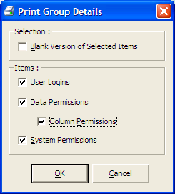

Selecting Blank Version of Selected Items, will print a blank list of all items. The user can then use this as a checklist before creating the details in Security Manager.

Selecting User Logins, will print the user logins details for the User Group highlighted.

Selecting Data Permissions will print the data permissions details for the User Group highlighted.

Selecting Column Permissions will print the column permissions details for the User Group highlighted.

Selecting System Permissions will print the system permissions details for the User Group highlighted.

Tools

Licence Information
From the Tools menu, choose Licence Information.

You will be presented with the following screen:

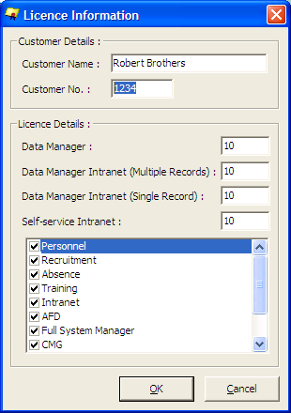

Your Company Name and Customer No. will be show on this screen.

Under Modules there is a tick next to the modules that are currently installed on your system.

Module Licences are used by ASR Computers to activate new modules within HR Pro and requires an authorisation code to make changes.

This screen will tell you how many users you are currently licensed for. The example shown above is licensed for 10 users for the Data Manager, which means that 10 people can be simultaneously logged into HR Pro.

There can be a greater number of users with passwords, but only 10 of them can use the system at the same time with the current license limits. Users for the Data Manager Intranet and Self-service Intranet modules are licensed individually.

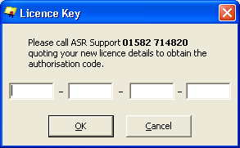

If you wish to increase the number of User Licenses, call ASR Support who will issue you with an authorisation number which should be entered into the screen shown above.

Security Options

Consists of two tabs:

- Security Policy
- Advanced

Password Options

From the Tools menu, choose Security Options and select the tab named Security Policy.

You will be presented with the following screen:

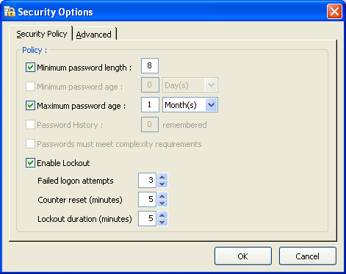

Minimum Password Length: The minimum length for a password.

Minimum Password Age: The time that must pass before a user is allowed to change their password. This feature is only available in SQL2005.

Maximum Password Age: The amount of time that passes after which the user is forced to change their password.

Password History: The amount of previous passwords that are remembered and cannot be used. This feature is only available in SQL2005.

Passwords must meet complexity requirements: A password must contain characters from three of the following four categories – uppercase, lowercase, numeric, and special. It must also be a minimum of six characters long. This feature is only available in SQL2005.

Failed logon attempts: The amount of attempted passwords before the account is locked. In SQL2005 lockout values are maintained by the server and not by client PCs. This means that once an account is locked, it’s locked from all workstations.

Counter reset: The period of time (in minutes) in which invalid logon attempts are tracked.

Lockout duration: The amount of time (in minutes) that a locked out account remains locked.

The settings in SQL2005 will always be disabled as they are inherited from the domain policy. Changes to these settings will need to be done by an administrator in Active Directory.

Advanced

From the Tools menu, choose Security Options and select the tab named Advanced.

You will be presented with the following screen:

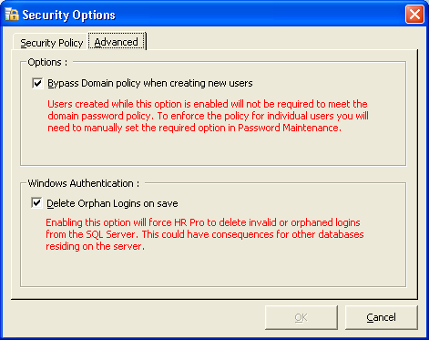

Bypass Domain policy when creating new users – Users created while this option is enabled will not be required to meet the domain password policy. To enforce the policy for individual users you will need to manually set the required option in Password Maintenance.

Tick Delete Orphan Logins on save - check box, this will delete any Windows Users and/or Groups from The SQL server if they no longer exist on the Windows domain.

Password Maintenance
From the Tools menu, choose Password Maintenance.

You will be presented with the following screen:

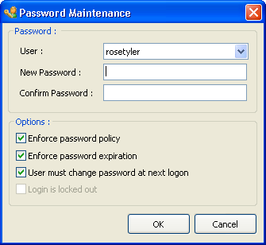

Select the User you wish to maintain.
Password Maintenance has four options:

- Enforce password policy
- Enforce password expiration
- User must change password at next logon
- Login is locked out

Enforce Password Policy: Here you have an option to disable the policy for an individual user. This feature is only available in SQL2005. This does not affect the case sensitivity of passwords. You’re stuck with that!

Enforce Password Expiration: Here you can disable the password change frequency for an individual user. Lockout policies and complexity checks remain. This feature is only available in SQL2005.

User Must Change Password at Next Logon: For SQL2005 this feature can only be used if password expiration is enabled. Prior versions to SQL2005 this setting was controlled by the HR Pro database, now it’s enforced by the SQL Server.

Login is locked out: SQL2005 only. If a user has had his account locked out this option gives an administrator the facility to unlock it. NB To unlock an account they must also provide a new password. In prior versions there was no facility to unlock an account.

Utility Ownership
This option allows you to transfer the ownership of a User’s reports, tools and utilities to another user. In the example below, ownership of all <All> items will be transferred to Admin. This is particularly useful when a person leaves and their work/tasks need to be passed on to somebody else.

From the Tools menu, choose Utility Ownership.

The following screen will be displayed:

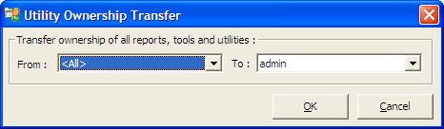

Select the user who you are transferring ownership From and then select the user who you are transferring ownership To.

Click the OK Button to make the transfer.

Enable SQL Mail Stored Procedures

The following settings need to be enabled in the Surface Area Configuration Connections & Services;
Remote Connections – Local and Remote Connections
SQL Server Agents started

Microsoft SQL Native Client Install
In order to use the latest drivers Microsoft have released an MSI package for SQL2005 connectivity. This is used by HR Pro to integrate with the domain policy checking of passwords and will need to be installed on each machine where the Data, System, or Security Manager is run. It will also need to be installed on the IIS server if does not also host the SQL Database.

If your domain does not have any lockout or password changing policies then HR Pro will function correctly without this install, however you will experience issues when changing passwords if the policy changes at a later date.

Please Note: The Microsoft SQL Native Client Install will not install on the Windows NT4 platform.

Server DLL
Due to security restrictions placed on us by SQL2005; it is now vital that the HR Pro Server DLL is installed and the SQLServerAgent is running as a local or domain administrator on the SQL server.

This is also required for the addition/manipulation of Windows authenticated users, and database locking.

Password Case

In SQL7 and SQL2000 this setting is taken from the server collation sequence, and would typically be set to case-insensitive. In SQL2005 passwords are case sensitive and take the complexity settings and lockout policies from the domain. This setting can be overridden by utilising a third party security management dll. This is not recommended or supported by ASR.

If upgrading from a previous version of SQL be warned that the upgrade process maintains the case of the passwords depending on how it was created, e.g. if a user entered “MyPassword” they would have been able to use the password without case sensitivity, however the upgraded server will now only accept correctly formatted password. In HR Pro 2.16 the automatic user add created passwords exactly as the user entered (i.e. case sensitive), 2.17 onwards forced the passwords lowercase behind the scenes.

Password and Lockout Policy
In SQL7 and SQL2000 these settings are taken from the database. In SQL2005 the settings are taken from the domain. The settings can be viewed in Security Manager->Security Options:

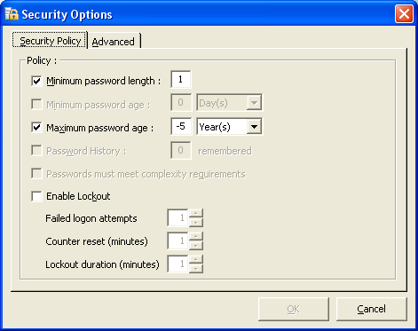

Minimum Password Length: The minimum length for a password.

Minimum Password Age: The time that must pass before a user is allowed to change their password. This feature is only available in SQL2005.

Maximum Password Age: The amount of time that passes after which the user is forced to change their password.

Password History: The amount of previous passwords that are remembered and cannot be used. This feature is only available in SQL2005.

Passwords must meet complexity requirements: A password must contain characters from three of the following four categories – uppercase, lowercase, numeric, and special. It must also be a minimum of six characters long. This feature is only available in SQL2005.

Failed logon attempts: The amount of attempted passwords before the account is locked. In SQL2005 lockout values are maintained by the server and not by client PCs. This means that once an account is locked, it’s locked from all workstations.

Counter reset: The period of time (in minutes) in which invalid logon attempts are tracked.

Lockout duration: The amount of time (in minutes) that a locked out account remains locked.

The settings in SQL2005 will always be disabled as they are inherited from the domain policy. Changes to these settings will need to be done by and administrator in Active Directory. This document does not cover how to do this.

Password Maintenance and Reset
When an account is created in SQL2005 it takes a snapshot of the domain policy and remembers it for each user. These are the settings that remain for that user until it is either locked or a password change is required. For example a user is created when the domain policy is set to force a password change every 1 month; if the domain policy changes to force a change every week, this user will not be required to change for whatever time of the original month is left. From this point they will now be forced to change every week:

Enforce Password Policy: Here you have an option to disable the policy for an individual user. This feature is only available in SQL2005. This does not affect the case sensitivity of passwords. You’re stuck with that!

Enforce Password Expiration: Here you can disable the password change frequency for an individual user. Lockout policies and complexity checks remain. This feature is only available in SQL2005.

User Must Change Password at Next Logon: For SQL2005 this feature can only be used if password expiration is enabled. Prior versions to SQL2005 this setting was controlled by the HR Pro database, now it’s enforced by the SQL Server.

Login is locked out: SQL2005 only. If a user has had his account locked out this option gives an administrator the facility to unlock it. Note: To unlock an account they must also provide a new password. In prior versions there was no facility to unlock an account.

Miscellaneous SQL2005 Issues
- SQL2005 checks for a forced password change before allowing access to any data: this means that a user will get prompted to change their password before any module access checks are made, i.e. a user with no access to HR Pro will get prompted to change their password before they’re told they can’t use HR Pro.

- In SQL2005 only users marked as “system” or “security” administrators within SQL can manipulate logins, this includes resetting passwords.

- In the advanced tab of security options there is a facility to disable the policy when creating new users. This is the same as disabling “Enforce Password Policy”. All password checks including expiry will not be applied for any new user created while this setting is in place.

Help

Contents and Index
Click the Contents and Index option and the Online HR Pro Security Manager files will be displayed as below:

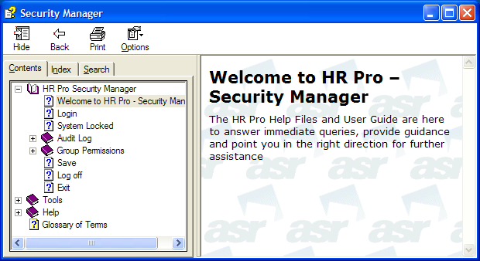

Contents tab – Gives a full table of contents for the help system. You can view different help by expanding the topics this will then show a list of sub topics and/or help pages. . See example below:
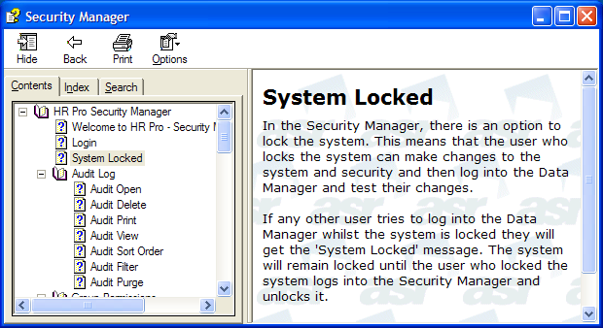
To view a help page Click the help page icon in the right hand pane and you will see all help related topics.

Index tab– Gives the option to search for specific words or phrases, or choose from a list of keywords.
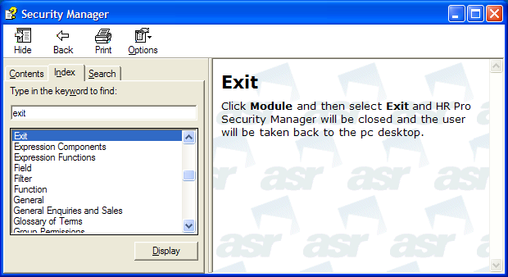

Type in the word you wish to find help on i.e. Exit, Click the Display button this will then highlight a match and show the help page in the right hand pane.
Search tab – Gives the option to type in word(s) to search for.
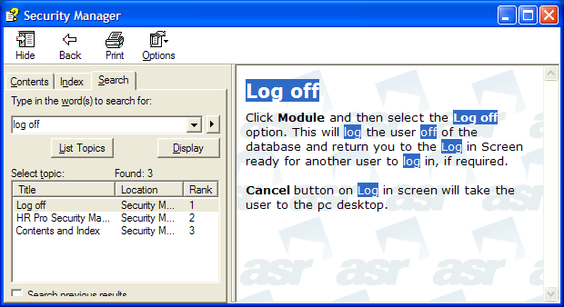

Type in the Word(s) you wish to find help on i.e. Log off, Click the List Topics button this will then display a list of topics. Highlight the one you wish to view then Click the Display button. The help page will highlight all the words which were in the search.

View Current Users
Click the View Current Users option form the Help Menu the following screen will be displayed, listing all the users that are currently logged on to HR Pro:

The screen shows the User name, their Machine and also the Module that they are logged into.

Click the Refresh button to force an update of the list of Current Users.

Lock Database enables the Administrator to lock the system to prevent other users logging on whilst he/she is working on it. The button toggles between Lock Database and Unlock Database.

If any user tries to log in to the Data Manager a message will be displayed telling them that the system is unavailable and also giving the User, Machine, Date and Time that the system was locked

If another user tries to log in to the Security Manager or System Manager a message will be displayed giving the same information as above. However, they will also be given the option of Proceeding with Read Only Access.

About HR Pro
This screen shows the version of HR Pro and SQL Server and also shows details of the Current User.

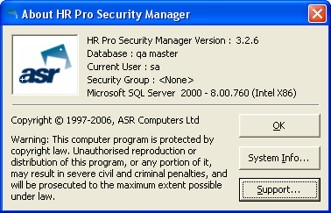

System Information

Click the System Info button to get information about the system.

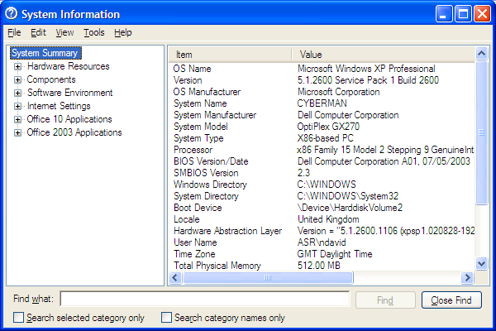

Click the Support button and a screen will appear. The screen shows the ASR Telephone Number, Email Address, Fax Number and Company Web Site.

Technical Support

In the screenshot below is a contacts page for Technical Support:

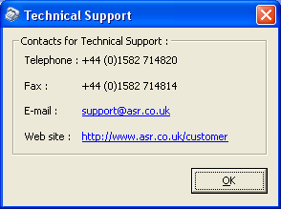

Contacting ASR

ASR Support
ASR Support operates from 09:00 until 17:30, Monday to Friday. The direct line telephone number is +44 (0)1582 714820.

All incoming calls are logged and the caller is issued with a Support Call Reference number which should be quoted in all future correspondence regarding the issue in question.

Please provide as much information as you can about the problem or query as this will help us to identify a solution as quickly as possible.

ASR Support can also be contacted by email. This can be done from within HR Pro.

Click the Help menu and choose the About HR Pro option.

Click the Support button.

Click the hyperlink to support@asr.co.uk and HR Pro will automatically open a new email with the correct email address already filled in.

Training Department
ASR's full time trainers are dedicated to providing a complete service for all your ASR training needs. In addition to the standard training courses we can also provide bespoke courses tailored to your own precise needs.

All our courses can be run in our training suite at ASR House or in your own offices.

If you have any questions or would like us to analyse your training requirements further, contact the Training Department at training@asr.co.uk

If you would like a course outline or wish to book any of our courses please contact our Training Co-ordinator at TrainingCoordinator@asr.co.uk

General Enquiries and Sales
If you have not found the answers you were looking for, or are looking for further assistance please contact us as below.

ASR Computers Limited contact details are as follows:

ASR Computers Limited
ASR House
Arden Grove
Harpenden
Hertfordshire
AL5 4SJ

Tel: +44 (0)1582 714 800
Fax: +44 (0)1582 714 814

For further product information please contact:

Email: Sales@asr.co.uk

Tel: +44 (0)1582 714810
Fax: +44 (0)1582 714814

ASR Support operates from 09:00 until 17:30, Monday to Friday.
The direct line telephone number is 01582 714820.

All incoming calls are logged and the caller is issued with a Support Call Reference number which should be quoted in all future correspondence regarding the issue in question.

Please provide as much information as you can about the problem or query as this will help us to identify a solution as quickly as possible.

ASR Support can also be contacted by email. This can be done from within HR Pro.

Click the Help menu and choose the About HR Pro option.

Click the Support button.

Click the hyperlink to support@asr.co.uk and HR Pro will automatically open a new email with the correct email address already filled

